116 Test Notes

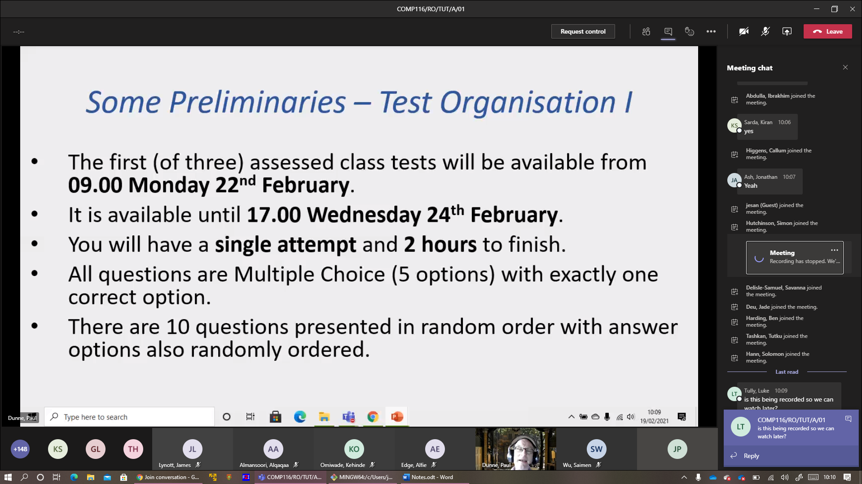

From 9am Monday next week till 5pm Wednesday

2 hours to finish, 1 attempt

MCQ, 1 correct answers

Can’t backtrack to previous questions

Vector movement/size

Vector spaces

E.g. drone at (10, 50, 0). Should move right by 5, climb 75. Answer = (15, 50, 75) – (x,y,z)

(x,y,z,t) – Time dimension

Euclidean distance: Is default. E.g. ||<1, -2, 2, -4>|| = sqrt(1+4+4+16) = 5

Vector spaces: Question gives definition of a set of vectors, and ask for 1 true/false statement

E.g. Q) {<p,q,r> E every integer z from 3 to 8: pq = qr}

H = Z8 is {0,1,2,3,4,5,6,7} and arithmetic is modulo 8

E.g. 7 + 3 = 10. Modulo 8 = 2, which is in the set

a) S is closed under scalar multiplication = False

b) S Iis not closed under addition = True

<1,1,0> + <1,1,0> = 2. <1,1,0> = <2,2,0> - doesn’t belong to the set 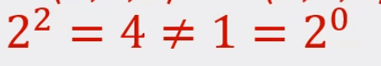

c) Set contains <0,1,1> = False Since 01 = 1 (not between 3 to 8). 11 =1, not satisfy the condition

d) S is a vector space = False

e) S does not contain <1,1,0> = False

Matrices and Graphical Effects

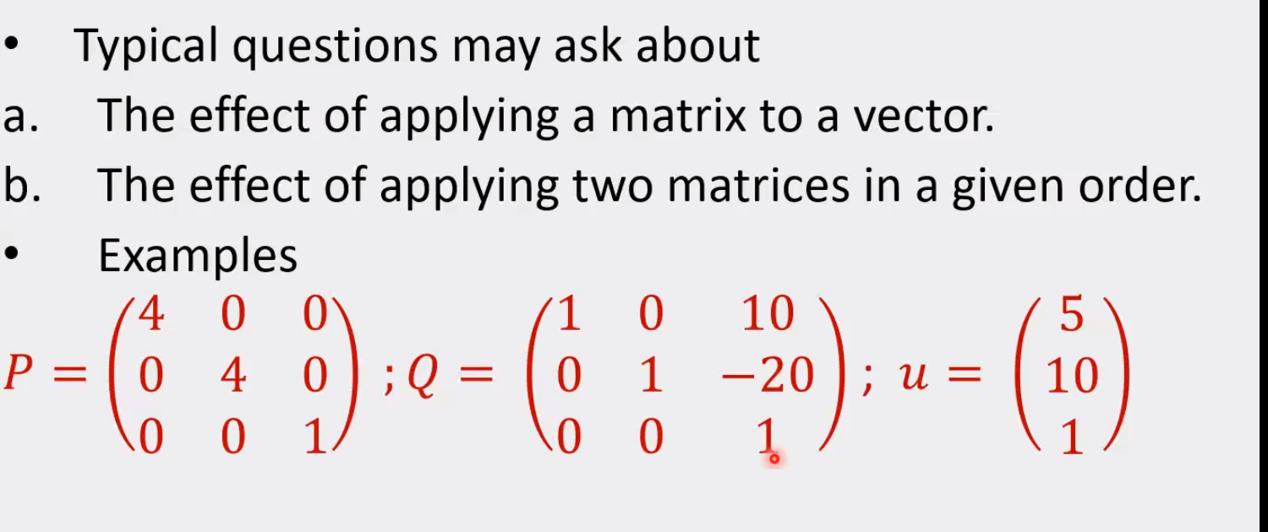

What point displayed after P . Q . u?

1. Multiply matrices, then apply to vector u

Or 2) 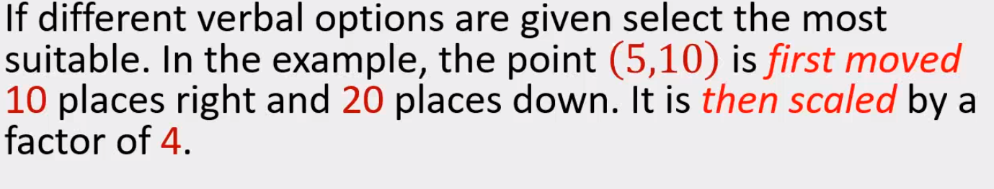

Not the same as Q.P.u – even though applies Q first

Are allowed to use online calculators